**Importing The Required Libraries**

Lets first import the libraries

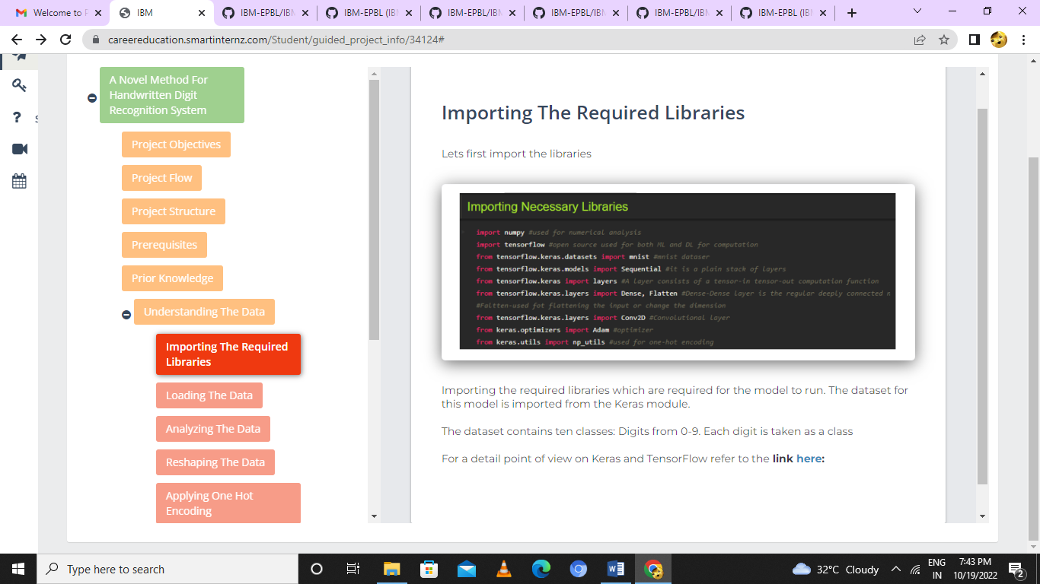

Importing the required libraries which are required for the model to run. The dataset for this model is imported from the Keras module.

The dataset contains ten classes: Digits from 0-9. Each digit is taken as a class

For a detail point of view on Keras and TensorFlow refer to the**link**[**here**](https://www.upgrad.com/blog/the-whats-what-of-keras-and-tensorflow/)**:**